# INV: How should DateTimeSelect support time increments?

**TL;DR:** Summary & Recommendation

Customer Problem

Questions to answer

Square

Harvest.io

Toggl

Apple Design

Google Material Design

Timecapture-DS

Prototypes

Summary & Recommendation

## Customer Problem

**As an** admin of a company with over 50 workers **I need to** create or edit timesheets for my workers **but** the fields to enter time make me select from a long dropdown list **which makes me feel** overwhelmed and frustrated when I have to search a long list of time increments for many timesheets.

## Questions to answer

1. How do competitors handle entering and selecting time?
2. How can we better support mouse, keyboard, and screen reader users?
3. Can we simplify input by formatting automatically vs field validation?

## Square

* <https://squareup.com/us/en/staff/shifts>

### New shift

* 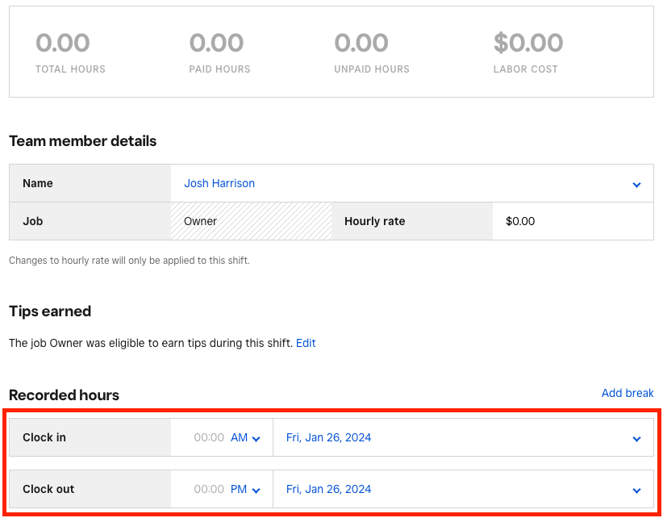
* Input field, no popup or list
  + Editable inline
  + Force format as HH:MM (you must type ##:##, it will not auto-format in any way)
    - 15 -> 1:50
* Select dropdown for AM/PM choice
* Date field is a clickable div that brings up a popup date picker
  + 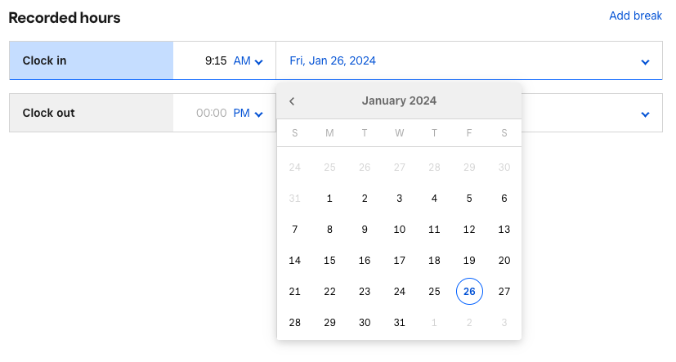

### Create Appointment

* 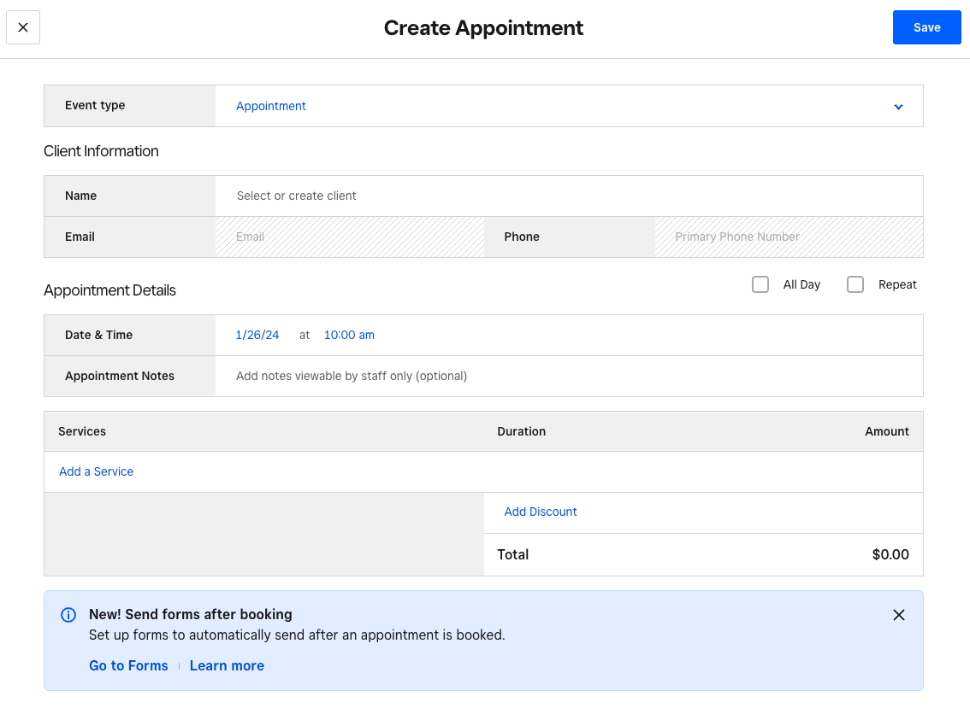
  + Date Picker uses different control than Shift
    - 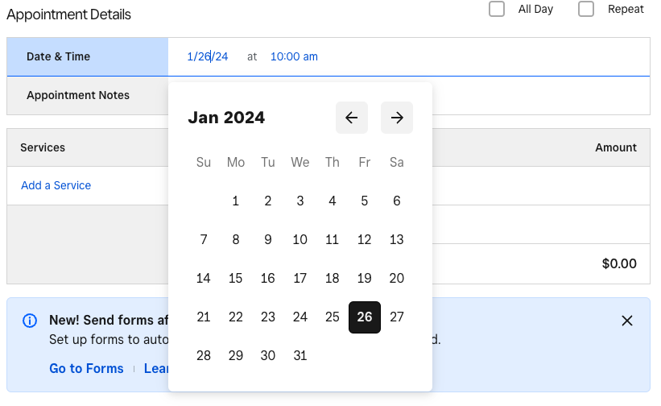
  + 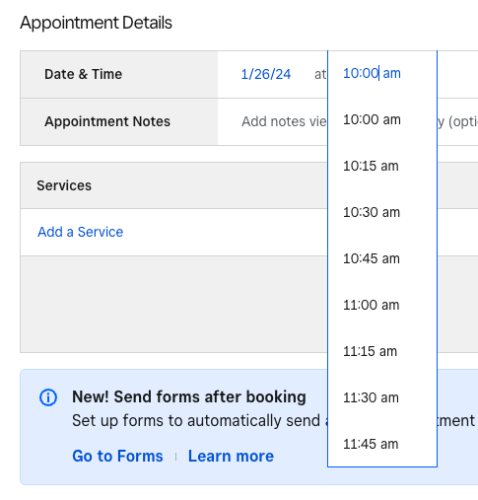
    - Input field with popup listbox
      * Select a time from the scrollable list
      * Manually enter a time, format HH:MM
      * Auto-formats to HH:MM
        + 5.15 -> 5:15 AM
        + 13.13 -> 1:13 PM

### Add to waitlist

* 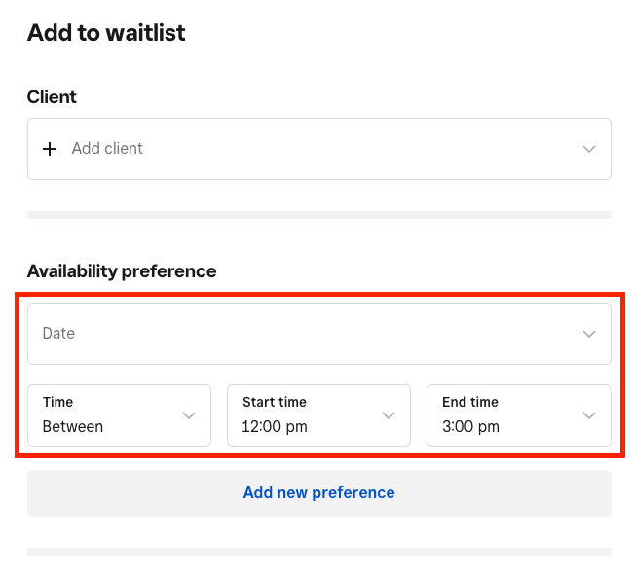
* Input field with popup listbox and auto-complete
  + 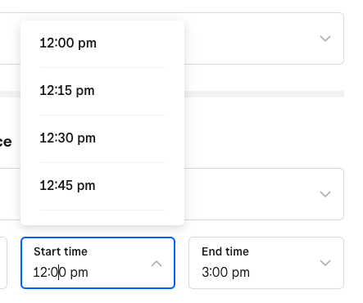
    - Select predetermined time from popup list
    - Manually type and auto-complete formats the list to match
      * 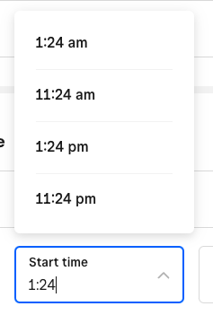
    - Doesn’t auto-correct if you don’t select a result
      * 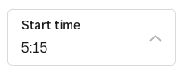

## Harvest.io

* <https://www.getharvest.com/>
  + Settings available to switch between time formats
  + 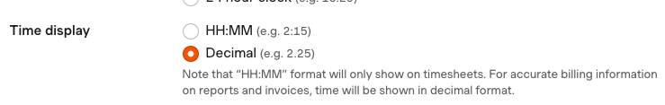

### New Time Entry (format HH:MM)

* 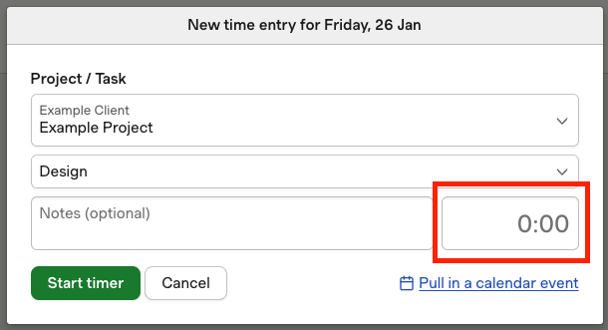
* Input field, no popup or list
  + Editable inline
  + Auto-formats as duration HH:MM
    - 100 -> 100:00
    - 6.15 -> 6:09
    - 6:15 -> 6:15

### New time entry (format Decimal HH.MM)

* 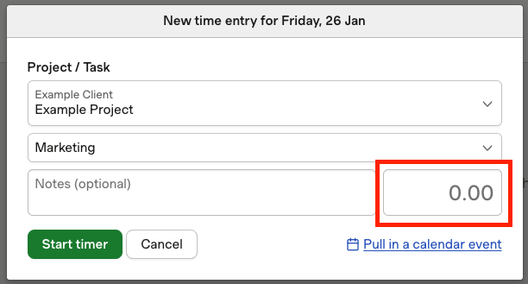
* Input field, no popup or list
  + Editable inline
  + Auto-formats as duration H.MM
    - 100 -> 100.00
    - 6.15 -> 6.15
    - 6:15 -> 6.25

### Weekly time entry (format HH:MM)

* 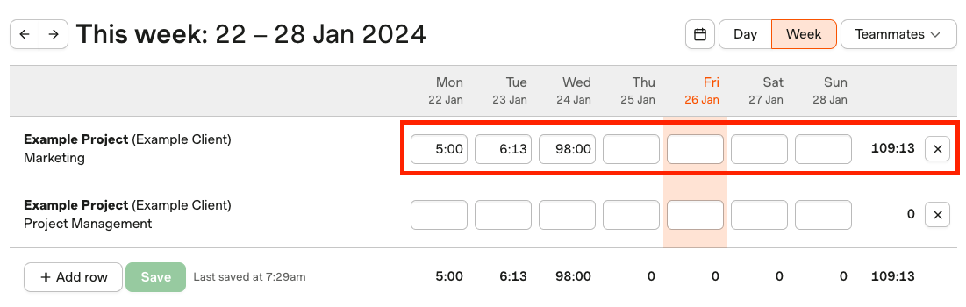
* Input fields, no popup or list
  + Editable inline
  + Auto-formats as duration HH:MM
    - 100 -> 100:00
    - 6.15 -> 6:09
    - 6:15 -> 6:15

### Weekly time entry (format Decimal HH.MM)

* 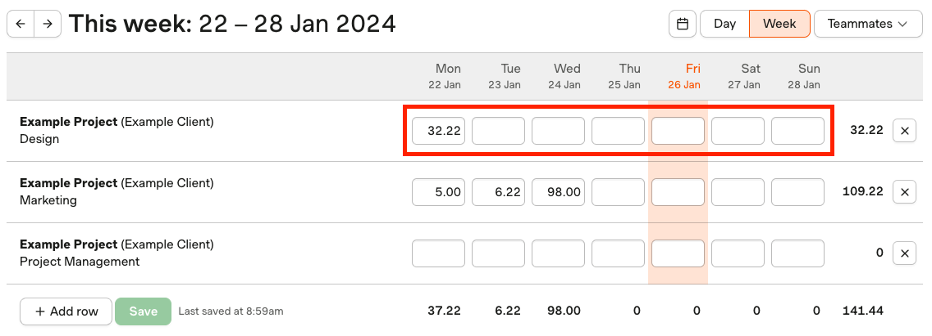
* Input fields, no popup or list
  + Editable inline
  + Auto-formats as duration HH:MM
    - 100 -> 100.00
    - 6.15 -> 6.15
    - 6:15 -> 6.25

## Toggl

* <https://toggl.com/>

### Manual Mode

* 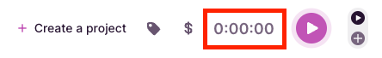
* Clickable input field (“Adjust duration” tooltip)
  + Editable inline
    - Auto-formats as a duration HH:MM:SS
      * 6:15 -> 6 hrs 15 minutes
      * 6.15 -> 6 minutes 09 seconds
      * 70.15 -> 1 hr 10 minutes 09 seconds
* Exposes date/time picker
  + 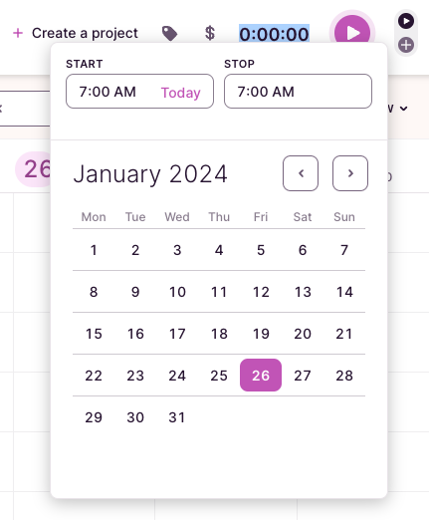
* 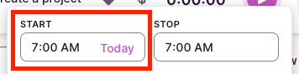
  + Clickable input field
    - Auto-formats to HH:MM A
      * 6 -> 6:00 AM
      * 6.5 -> 6:05 AM
      * 6:98 -> error
      * 6:00 a -> 6:00 AM
      * 6a -> 6:00 AM
* 
  + Time shown as a duration HH:MM:SS

### Timer Mode

* 
* Clickable input field
  + Auto-formats to HH:MM A
    - 6 -> 6:00 AM
    - 6.5 -> 6:05 AM
    - 6:98 -> error
    - 6:00 a -> 6:00 AM
    - 6a -> 6:00 AM

## Apple Design

* <https://developer.apple.com/design/human-interface-guidelines/pickers>

### Notes

1. No Web- specific time-related components
2. All examples reflected this scrollable selector style

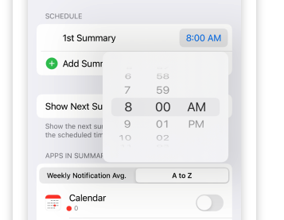

## Google Material Design

* Web: <https://material-web.dev/>
* Mobile: <https://m3.material.io/components/time-pickers/specs>

### Notes

1. For Web, there isn’t a design for a time-related component
2. Time Input and Time Selector (Mobile)

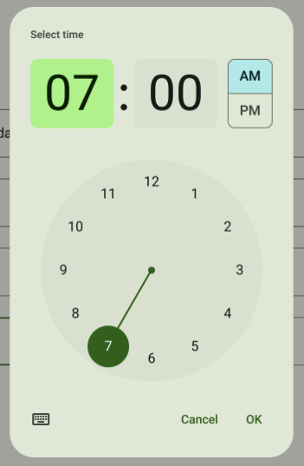

## Timecapture-DS

* <https://uxfabric.intuitcdn.net/internal/design-systems/timecapture-ds/master/latest/index.html?path=/story/components-time-select--basic-usage-with-knobs>
* 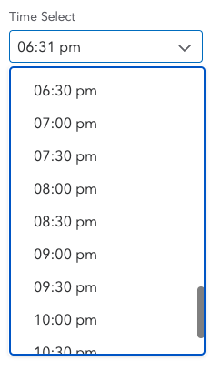

### Notes

* Uses @ids-ts/text-field for text input, time can be edited
* Creates a custom-built listbox dropdown for selecting predetermined times
* 1st click shows the dropdown, 2nd click lets you manually enter
* Auto-formats manually entered time
  + 5:30 -> 05:30 am
  + 15:30 -> 03:30 pm

## Prototypes

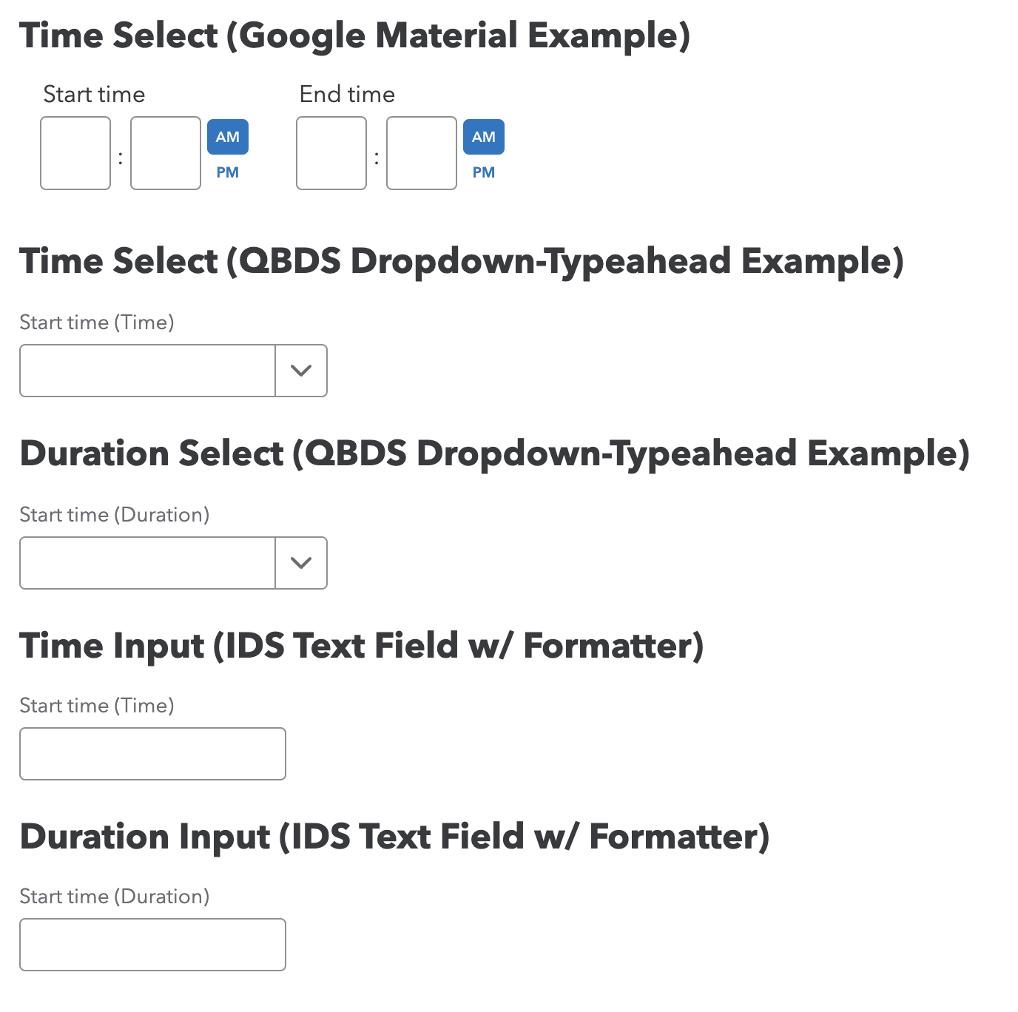

## Summary & Recommendation

Personally I found anything more than a simple text field with an auto-formatter on blur to be cumbersome and take too long to fill out. Providing a dropdown that also allows input is a flexible compromise, but once you have type in your time there’s no point in selecting anything. Also, using a simple text field can be reused across Time widgets as a durable, recognizable input component for time or duration.

1. Use the [IDS TextField](https://uxfabric.intuitcdn.net/internal/design-systems/ids-web/main/latest/index.html?path=/story/components-text-field--playground&platform=web&theme=intuit&colorScheme=light) input
   1. Benefits
      1. Flexible for Time or Duration
      2. Fast input for MM vs selecting from dropdown
      3. Can be re-used across widgets (Time Edit, Weekly Timesheet, etc.)
   2. Use customer setting to distinguish between 12 hr or 24 hr formats
   3. Use onFocus to auto-select the text
      1. 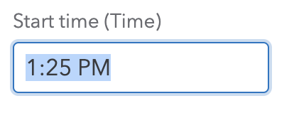
   4. Use onBlur custom formatter (not built-in formatter) for
      1. Adding AM or PM
      2. Forcing “:” or “.”, depending on type of field
      3. Align on HH:MM or H:MM format
2. Use the [QBDS DropdownTypeahead](https://uxfabric.intuitcdn.net/internal/design-systems/qbds/main/latest/index.html?path=/story/components-dropdown-typeahead--playground)
   1. Benefits
      1. Flexible for Time or Duration
      2. Can allow for input or selecting from dropdown
   2. Use customer setting to distinguish between 12 hr or 24 hr formats
   3. Use selectTextOnFocus prop to auto-select the text in the input field
      1. 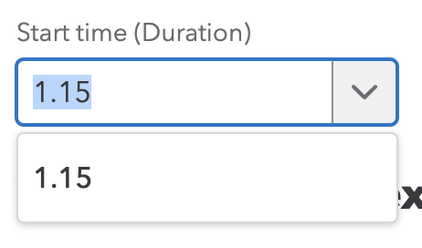
   4. Use onBlur custom formatter (not built-in formatter) for
      1. Adding AM or PM
      2. Forcing “:” or “.”, depending on type of field
      3. Align on HH:MM or H:MM format